Father and son age

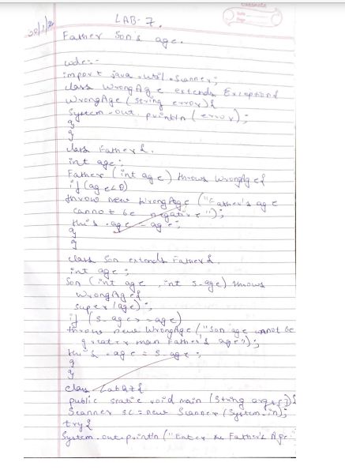

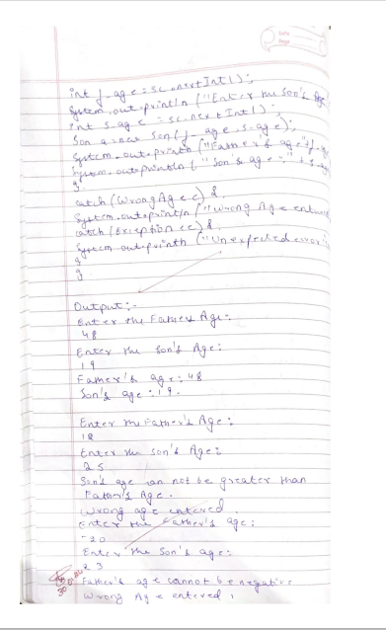

Code:-

import java.util.Scanner;  
class WrongAge extends Exception{  
WrongAge(String error){  
System.out.println(error);  
}  
}  
  
class Father{  
int age;  
Father(int age) throws WrongAge{  
if(age<0)  
throw new WrongAge("Father's age cannot be negative");  
this.age=age;  
}  
}  
  
class Son extends Father{  
int age;  
Son(int age,int s_age) throws WrongAge{  
super(age);  
if(s_age>=age)  
throw new WrongAge("Son'age cannot be greater than Father's age");  
this.age=s_age;  
}  
}  
  
class LabQ7{  
public static void main(String args[]){  
Scanner sc=new Scanner(System.in);  
try{  
System.out.println("Enter the Father's age:");  
int f_age=sc.nextInt();  
System.out.println("Enter the Son's age:");  
int s_age=sc.nextInt();  
Son a=new Son(f_age,s_age);  
System.out.println("Father's age:"+f_age);  
System.out.println("Son's age:"+s_age);  
}  
catch(WrongAge e){  
System.out.println("Wrong Age entered");}  
catch(Exception ee){  
System.out.println("Unexpected error :"+ee);}  
}  
}

output:-

